WHEELS 👨‍🔧⚙️👩‍🔧

The challenge, consisting of an obstacle course, has various obstacles such as the ‘Crater with Ejecta’, which requires the participants to drive their rover over craters of 6 feet diameter and 8 inches height. Such a challenge requires us to build strong wheels which are wide enough to sustain the aforementioned challenge. Also, the challenge requires us to design and fabricate non-pneumatic wheels.

The rover will consist of four wheels. All wheels will have the same diameter measuring *26 inches*. A total of 6 wheels will be manufactured; 2 for the front, 2 for the back and 1 spare for each of them.

 For each wheel, we will be using two standard rims used in cycles (details TBD). These rims will be welded together, while leaving a small gap between the two rims, such that the total edge-to-edge width of the two rims is between *5 to 6 inches*, and joining them by a *metallic sheet at the circumference* of the same material as rims. The thickness of the sheet would be around *2.5 - 3 mm*. Afterwards, for more security and strength, we will be welding small metal slits from the inside of the rims.This whole construction leads to an overall wheel of more than double the width of a standard cycle wheel.

Next, we focus on increasing the grip of the wheels. The double-rimmed wheel once covered with the metallic sheet will now be covered with a thick sheet of truck tyre rubber, of thickness around 1.5 cm. To stick the rubber sheet to the metallic part of the wheel, we will be bolting the rubber sheet to the wheel by drilling and tightening it by nuts from inside. To increase the grip of the wheel more, we will be drilling bolts onto the surface of the wheel on the sides and using nuts to fasten them from the inside.

The rough sketch below will help in giving an idea of how the bolts are placed.

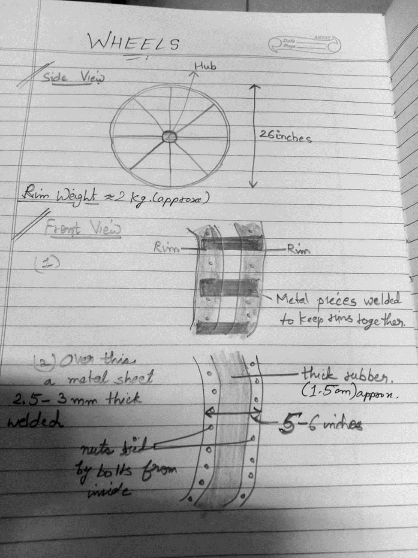

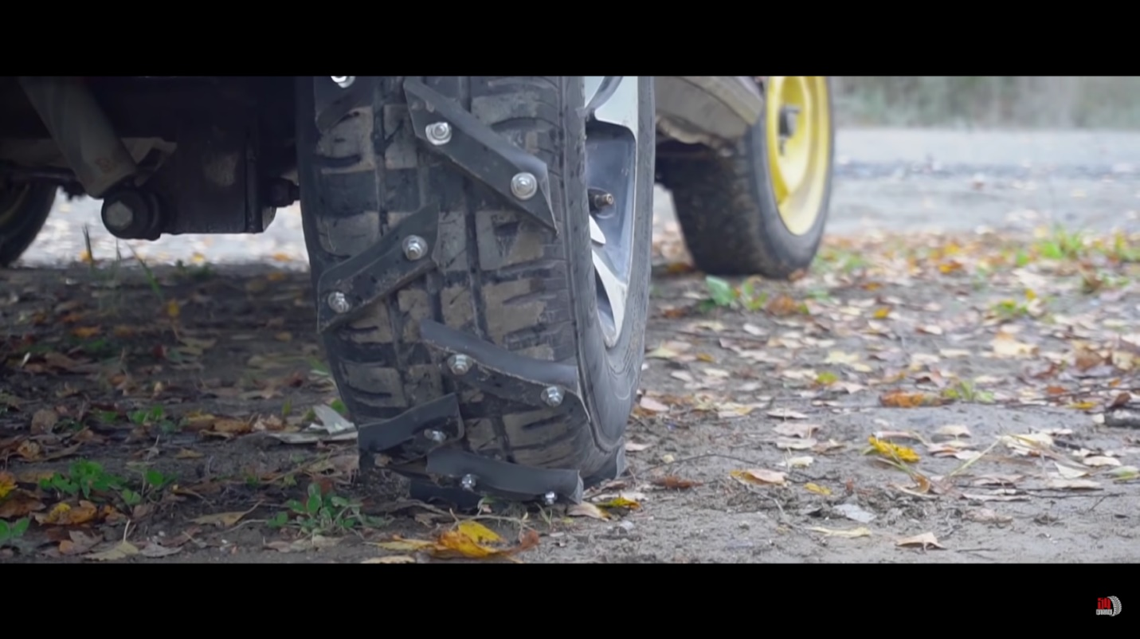

This is one more idea of how we can increase the grip and make our rover go over various uneven surfaces.

What we still need to work on

* What kind of rims will be used (what will be its material, number of spokes, strength, etc) ? (requires visit to Dadri cycle shops)
* The kind of materials used in the metallic sheet for the wheel? (depends on the material of the rim, needs to be easily weldable)
* Diameter of the shaft

References

1.   [Driving on handmade all-terrain tires - YouTube](https://www.youtube.com/watch?v=tD7Kkfh2rkA): This video has the construction of DIY all-terrain wheels, which uses the same idea for drilling bolts for added grip to the wheels.

2.             <https://www.amazon.in/BALAJI-STORES-Stainless-Steel-Cycle/dp/B0BQTYN31V/ref=sr_1_13?keywords=cycle+rim&qid=1673934628&sr=8-13>

CYCLE RIM-1

3.             <https://www.amazon.in/Autonix-Aluminium-Wheel-Spoke-Axle/dp/B08BXLLMRB/ref=d_pd_sbs_sccl_3_1/260-2155128-2001758?pd_rd_w=3cZl3&content-id=amzn1.sym.e2ce9e2f-6d12-4c08-abc6-a5b1e7e9208f&pf_rd_p=e2ce9e2f-6d12-4c08-abc6-a5b1e7e9208f&pf_rd_r=Q6D7WAPJCWRTP9KREBJS&pd_rd_wg=sVswl&pd_rd_r=37f93c47-9cd5-4526-8b65-42f074327f6b&pd_rd_i=B08BXLLMRB&psc=1>

CYCLE RIM-2

4.             <https://www.amazon.in/Invento-Aluminium-Alloy-Sheet-100x100x2mm/dp/B074FW2WLT/ref=sr_1_11?crid=THUNN6DEYK8W&keywords=metal+sheet&qid=1673957884&sprefix=metal+sheet+%2Caps%2C541&sr=8-11>

METAL SHEET